Step - 1– Login to IBM Cloud and go to Catalog
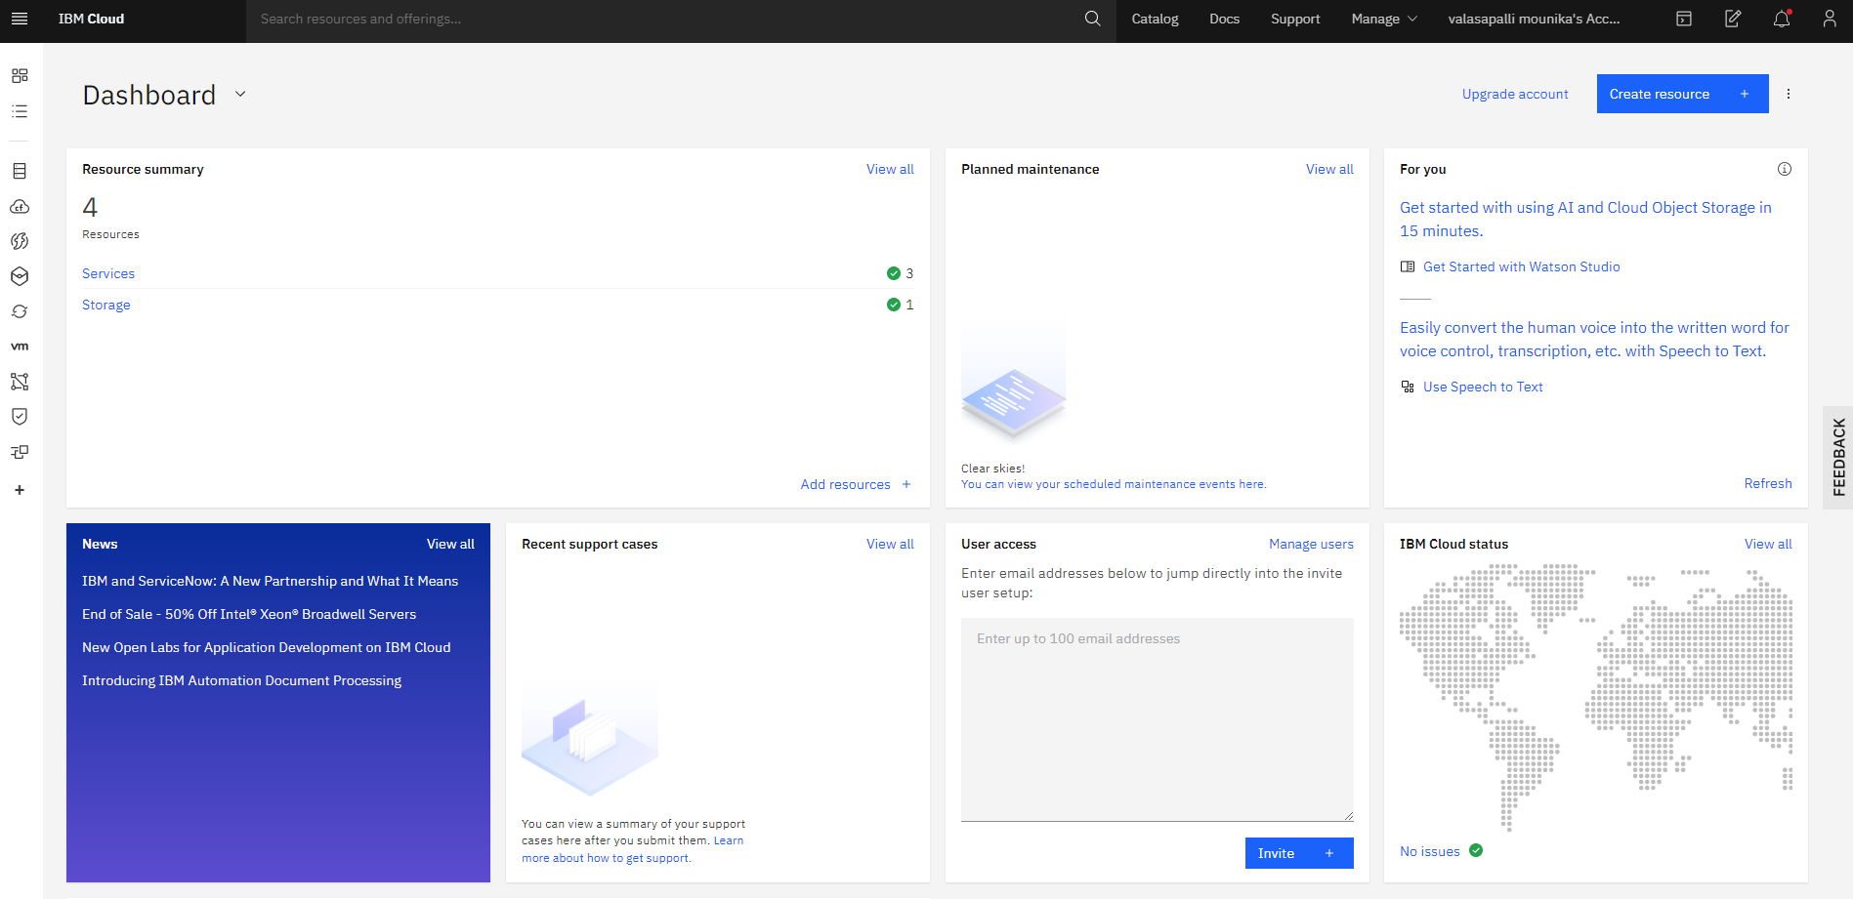
Step - 2– Go to Watson Services and open Watson Assistant
Step - 3– Give a service name and click on Create
Step - 4 – Click on Launch tool to launch the dashboard of IBM Conversation Service
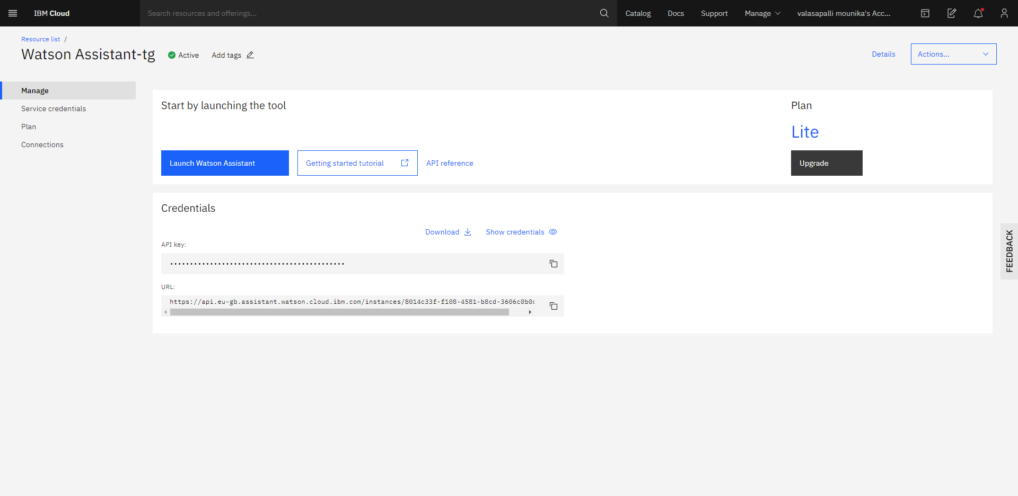

Step - 5– Click on Assistants and give name Smart Restaurant bot

Step - 6– Click on create Assistants

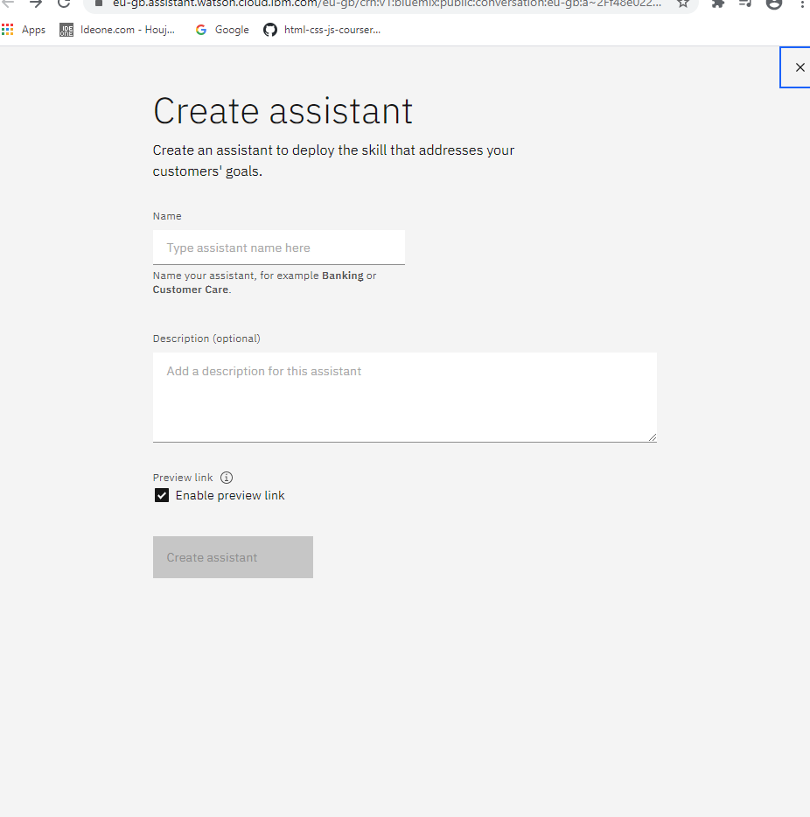

Step - 7–Click on Add intent to create a new intent name Greetings create

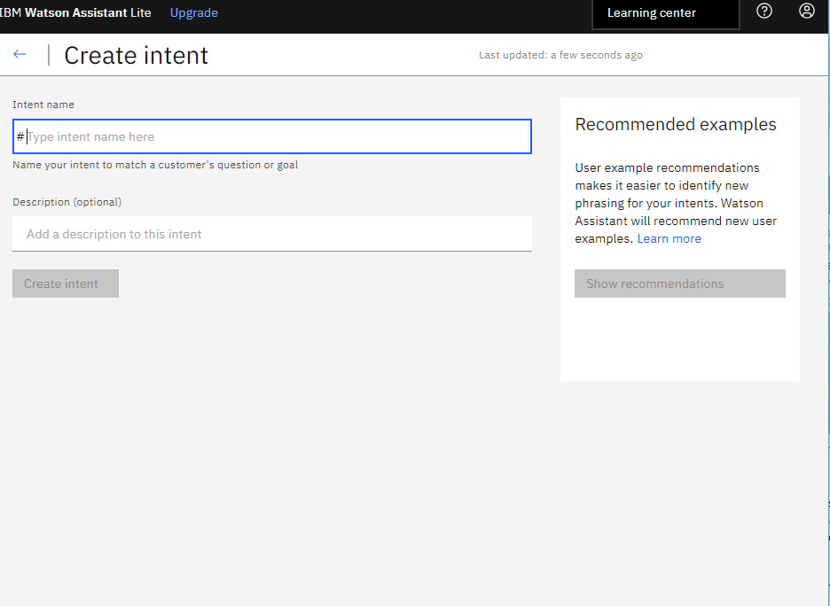

Step – 8: Add a user example and click on Add example and dd multiple examples to intent

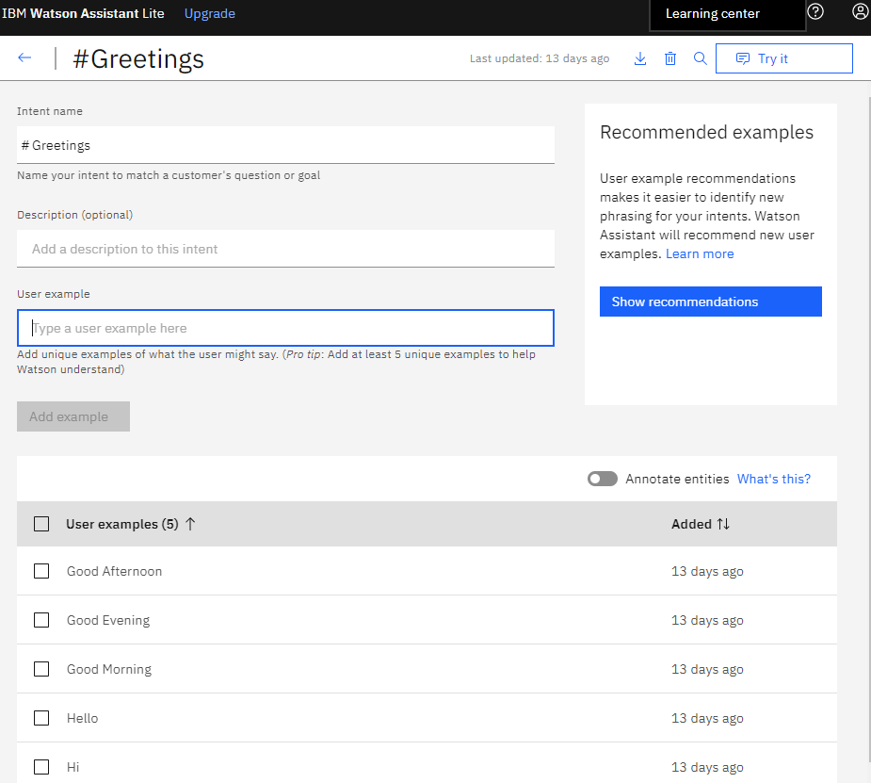

click on the left arrow(back button)

Step – 9: Click on Entity and name is greetings and the create entity

Step-10: Here give values for ex: good morning

Step-11: lick on add value 2. Good afternoon

Step-12: Click on add value 3. Good evening

Step-13: Click on the left arrow(back button)

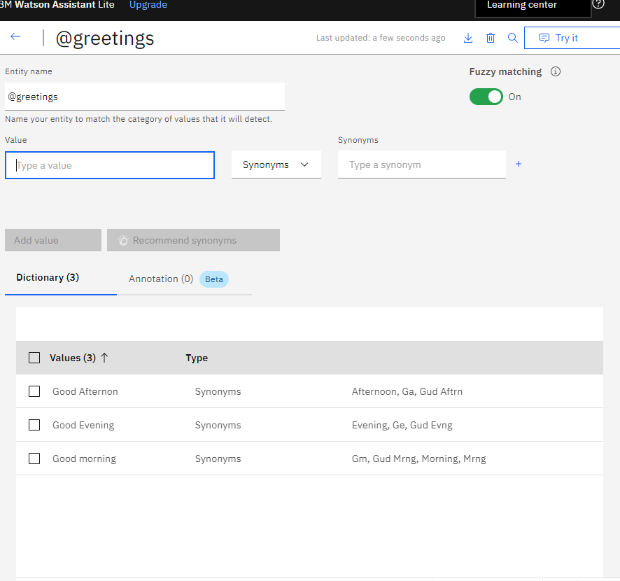

Step – 14 : Click on create to create the Dialog flow
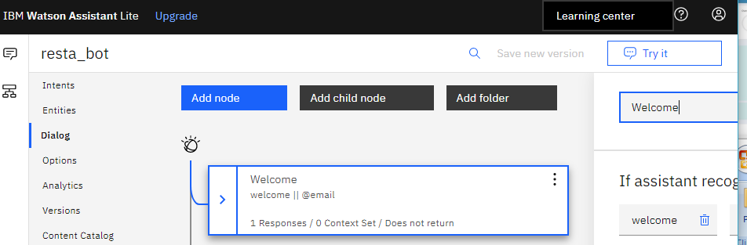
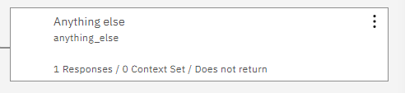
Here already I created .
Step – 15: Welcome and Anything else nodes are the inbuilt nodes which have their own functionality. Welcome node is executed during the start of the conversation, and Anything Else node is executed user question is irrelevant
Step --16: Click on welcome node click on 3 dots add node below.
Step – 17: Give a name to the node Greetings. Then select the Greetings option
Step – 18: Add sample responses and Click X to close the edit view.
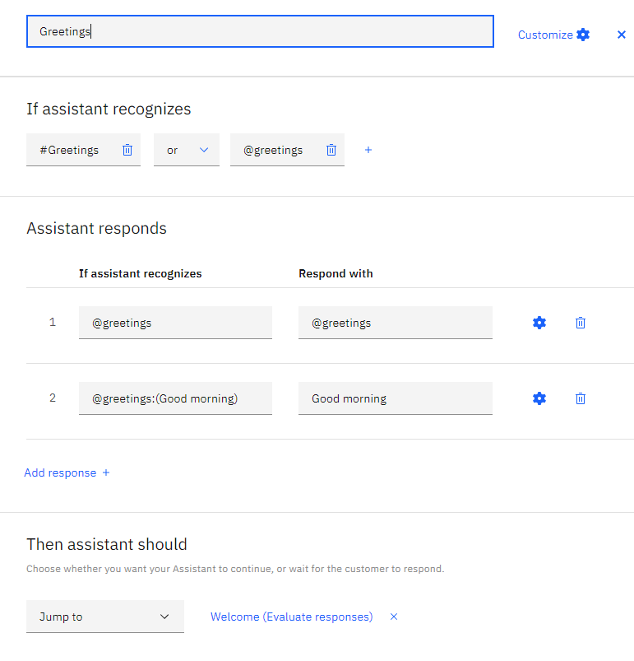
Step – 19: Test the dialog. Click the "Try it" icon to open the "Try it out" . 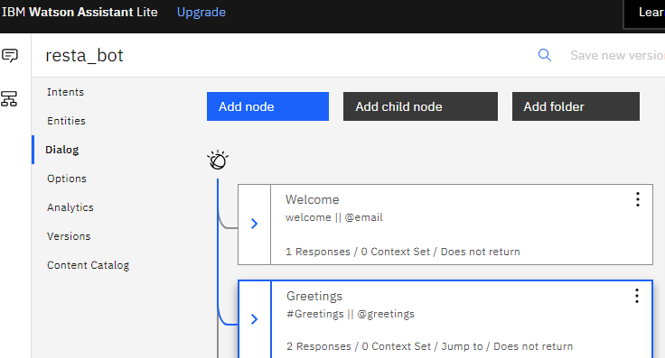

Step – 20:Enter a sample input to test your chatbot
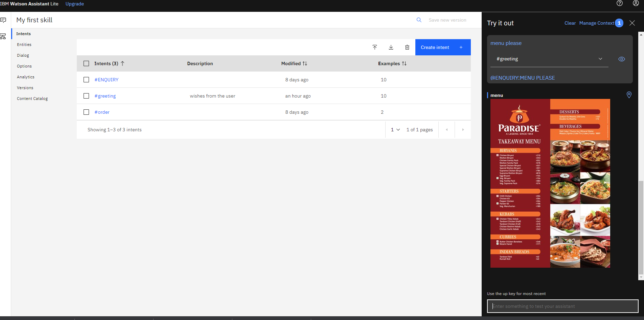
Step – 21: Here is the response by the Bot
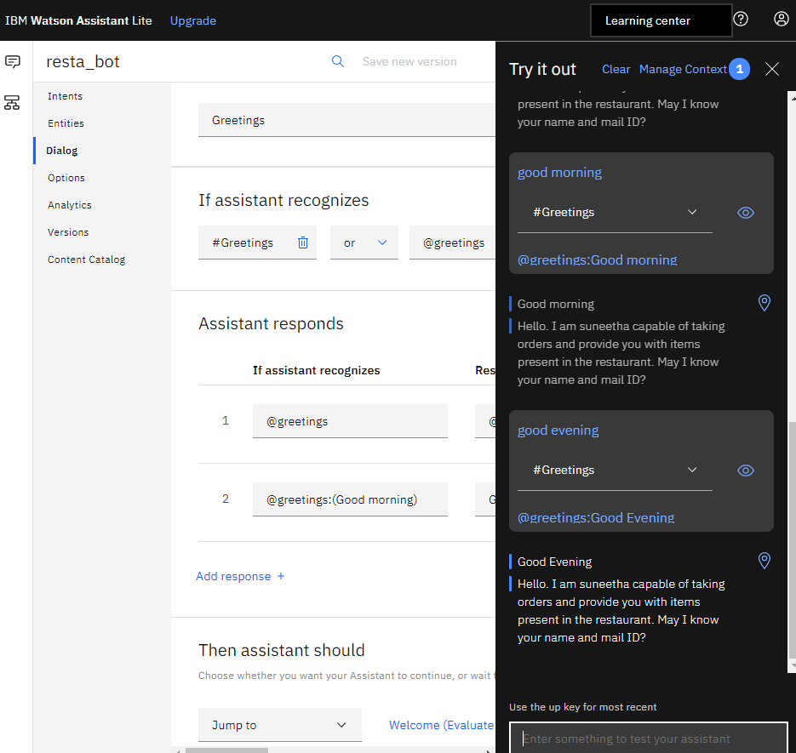
Step – 22: create an intent for Enquiry. So, go to Intents and click on “Add Intent”.

Step – 23: Give the intent name as Enquiry and click on create intent
Step – 24: Add the different user examples for Enquiry intent
Step – 25: After adding various examples click

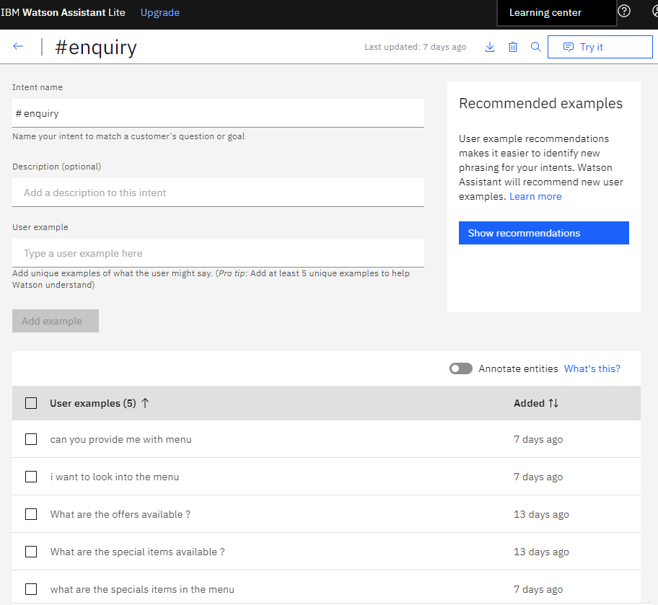

Step – 26: Click on Entities to create new entities
Step– 27: Click on Add entity
Step – 28: Give the name Enquiry and click on Create entity
Step – 29: Give the value name as offers and click on Add value.
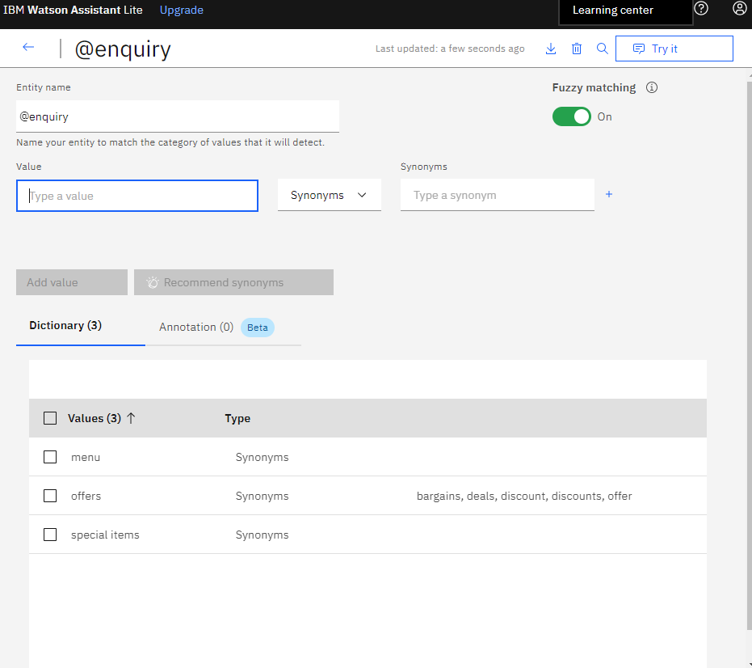
Step – 30: After adding two values (menu, offers,special items) click back button
Step – 31: Go to dialog
Step – 32: Click on Greetings and click on 3dots and click Add node below to for Enquiry
Step – 33: Give the name of the node as “Enquiry” and give the condition
Step – 34: Click on Customize to give the specific responses
Step – 35: Enable multiple responses and click on Apply
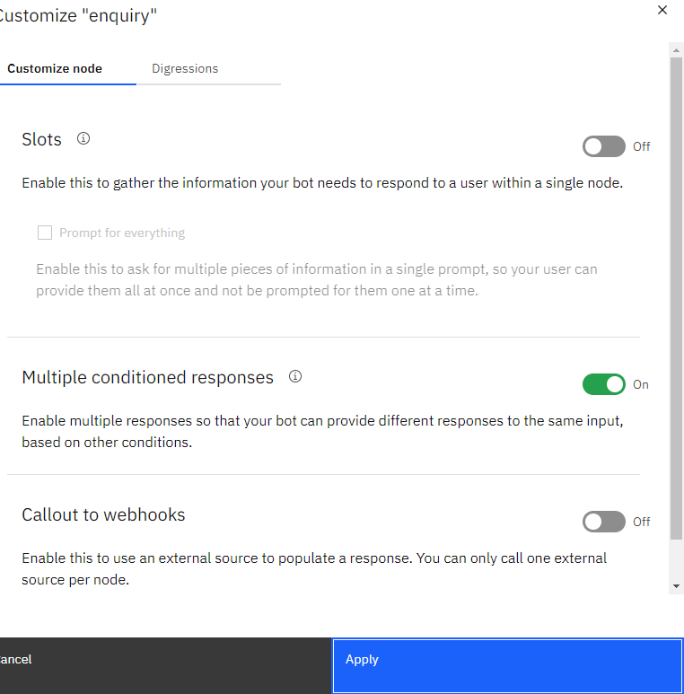

Step – 36: Enter @Enquiry and select the option
Step – 37: Select “: is” from the option’s
Step – 38: Select “offers” from the drop-down. So the first internal condition executes when the user question is about offers.
Step – 39: Give a sample response about offers
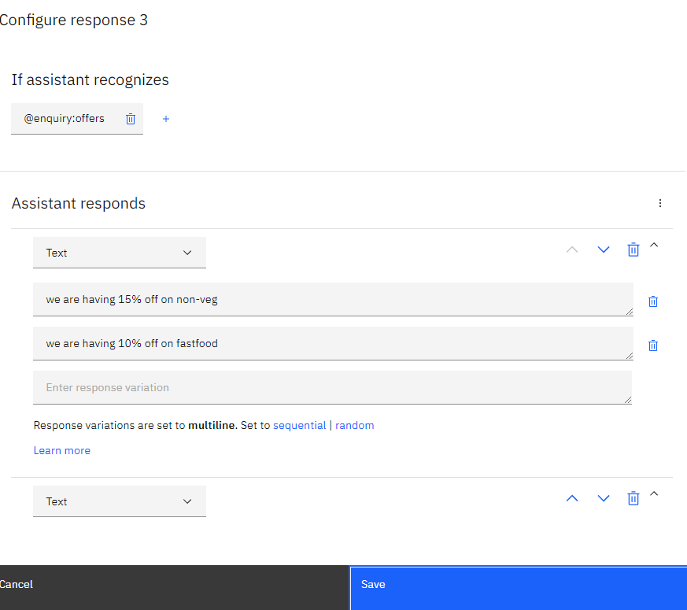
Step – 40: Click on Add response to add response for “menu”
Step – 41: Give the name “menu”
Step – 42: Click on settings to give an image response
Step – 43: Select Image from the options
Step – 44: Enter the “Title” as “Menu”, and give a sample Image URL of the menu in Image source
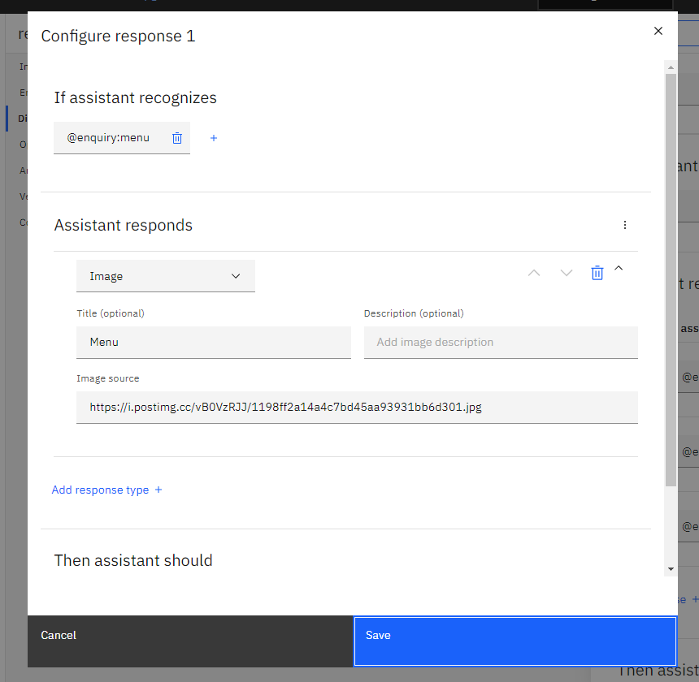

Step – 45: Click on Save
Step –46: Enter @Enquiry and select the items. Select “: is” from the option’s
Step –47 : Click on settings to give an option response
Step – 48 :Select option from the options
Step –49 : Enter the “Title” as “special items.
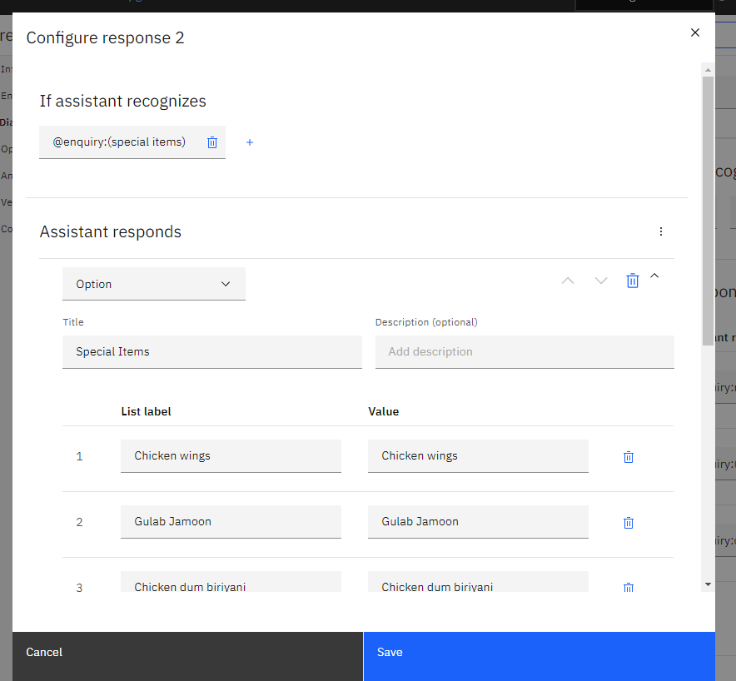

Step –50 : Click on Save

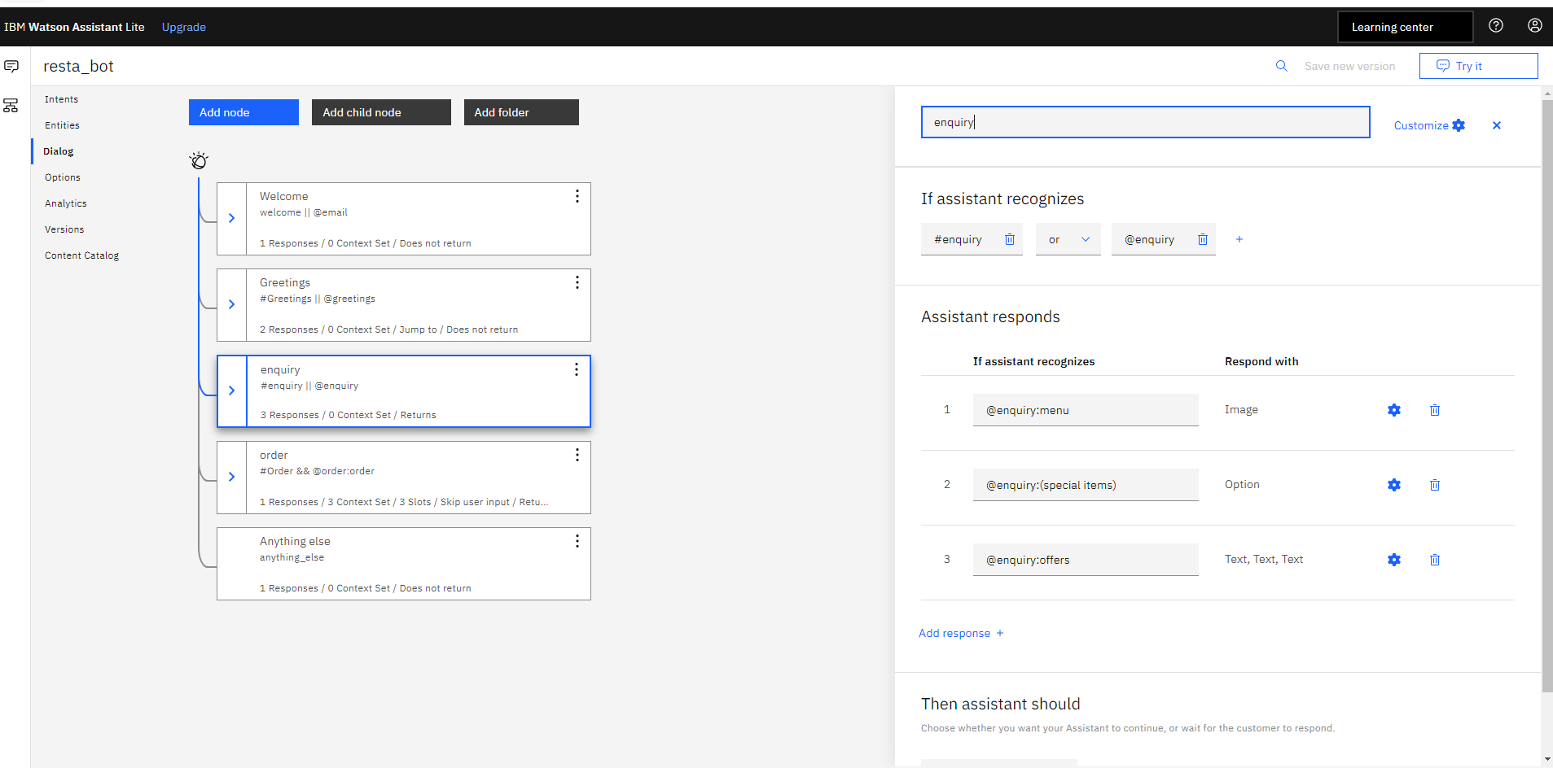
Step – 51: Click x to close the edit window
Step –52: Test the dialog. Click the "Try it" icon to open the "Try it out"
Step – 53: Observe the response by the bot

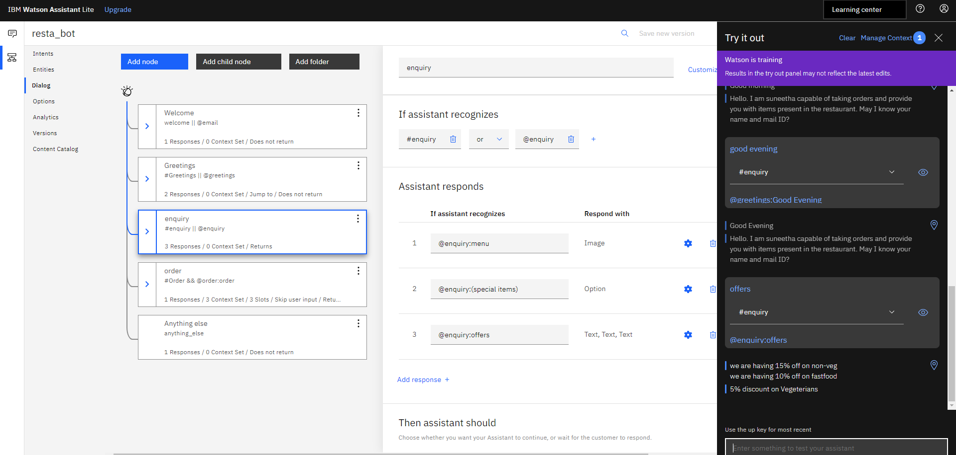

Step – 54: create Intent for ordering. go to Intents
Step –55: create Intent name order.
Step – 56: Give the name of the intent as Order
Step – 57: Add the sample user examples for #Order intent
Step – 58: Click on left arrow after adding user examples.
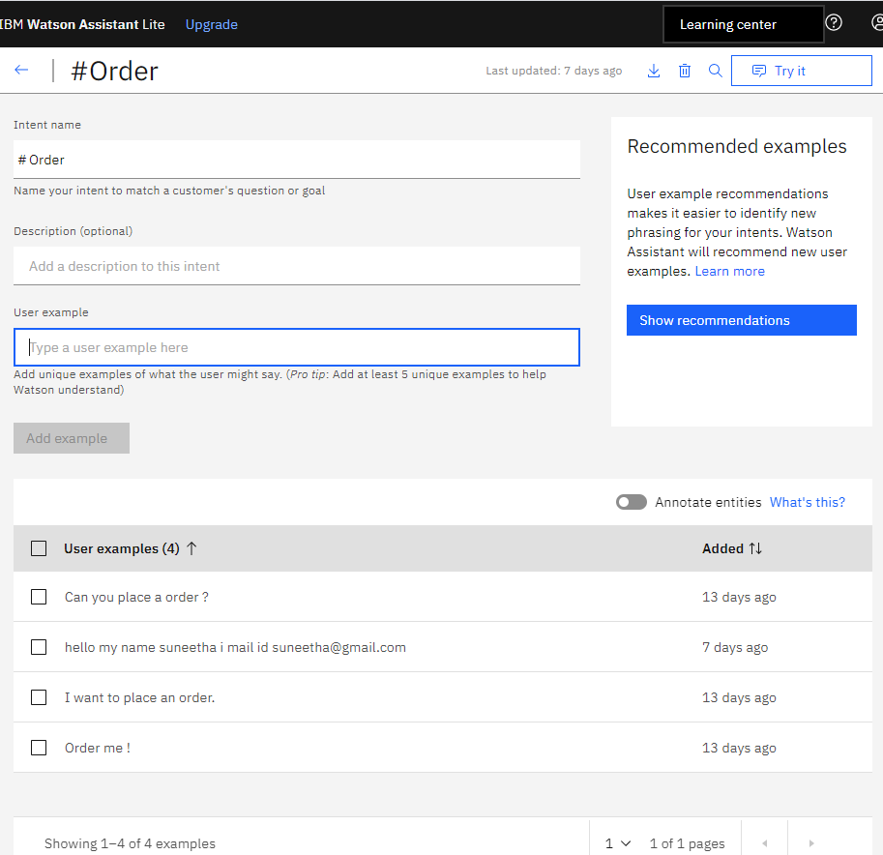

Step – 59: Go to Entities to add entities name order create entity

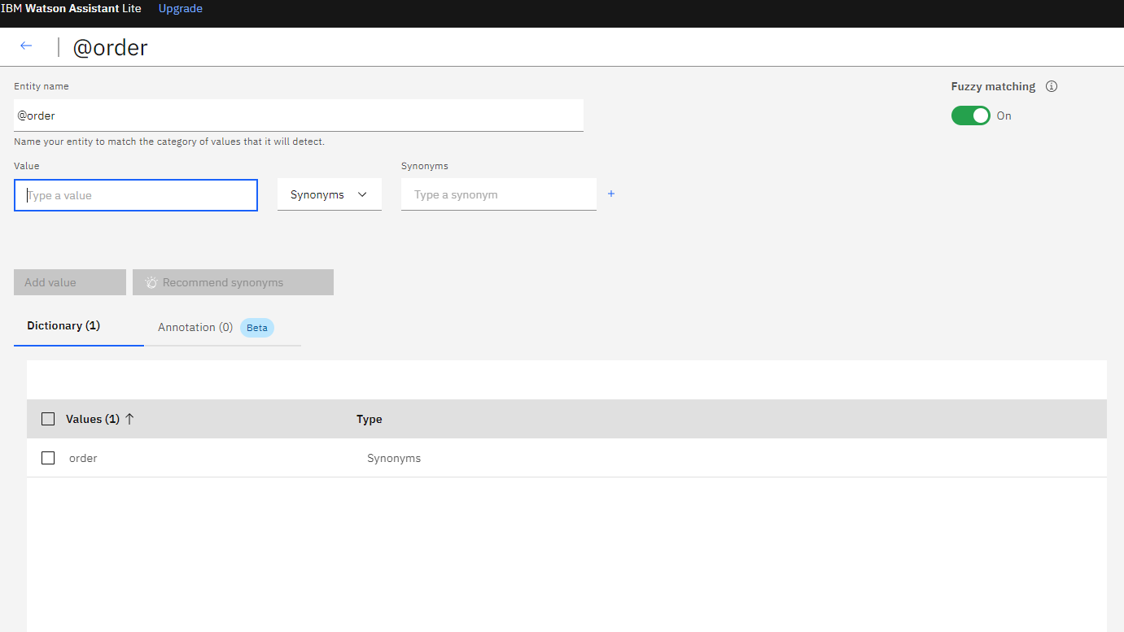

Step –60 : Go to dialog
Step –61 : Click on enquiry and click on 3dots and click Add node below to for order
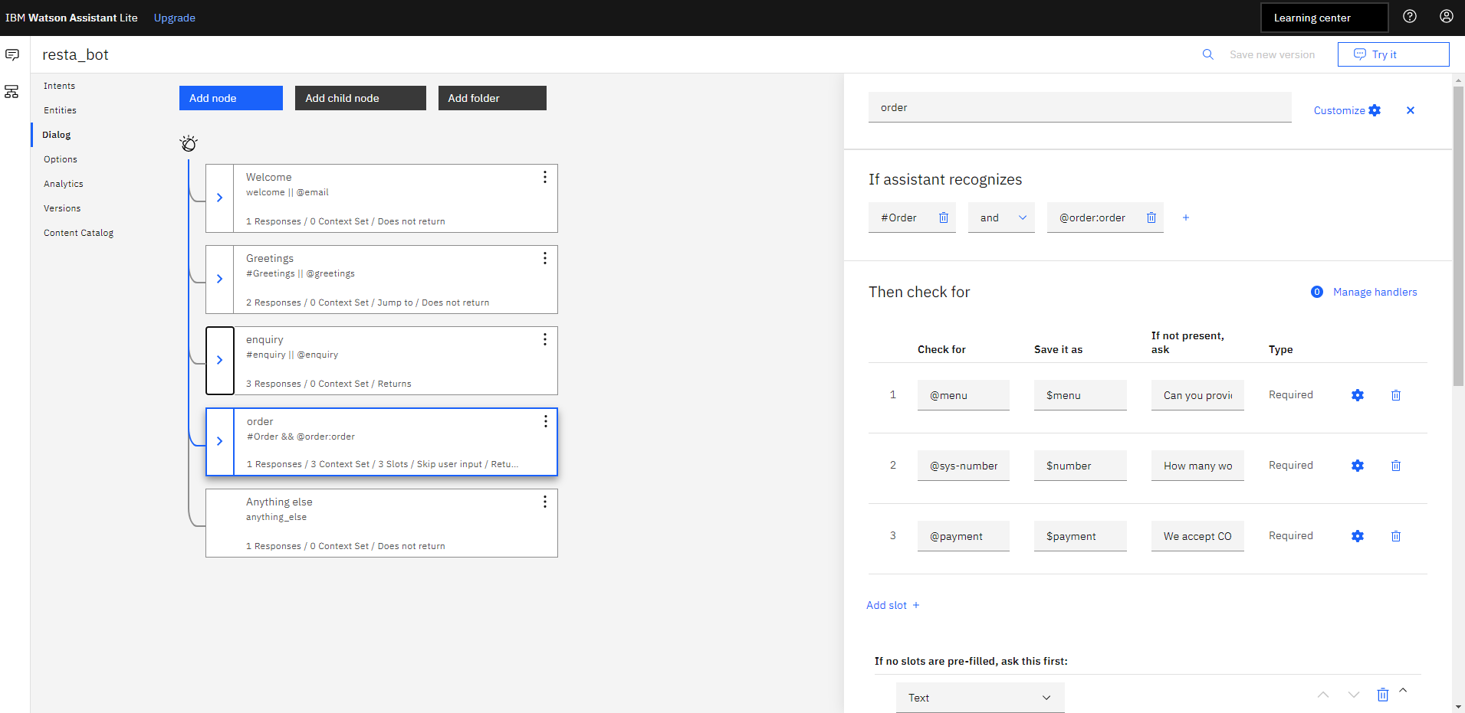

Step –62 : Click on “Customize” to give specific responses
Step – 63: Enable multiple responses and click on Apply
Step – 64: Click on "settings" to add the internal condition
Step – 65: Enter the first condition as “@items” and click on to add other condition i.e quantity
Step –66 : In the second condition select “@sys-number” i.e for Quantity
Step – 67: Give your confirmation response as shown below (Your order for @items of quantity @sys-number is ordered successfully)
Step –68 : click on save

Step – 69: Go to option click on System entities and enable “@sys-number” entity
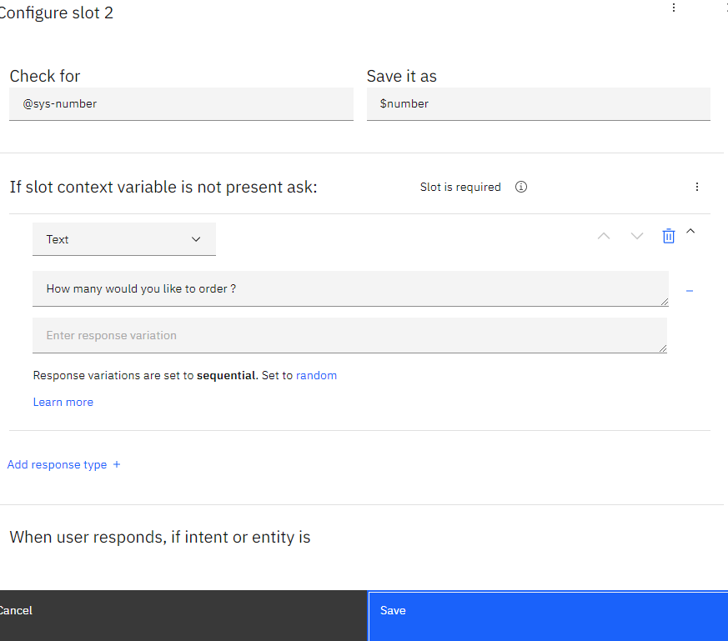
Step – 70: Click on Save
Step –71 : click on menu option give response like below

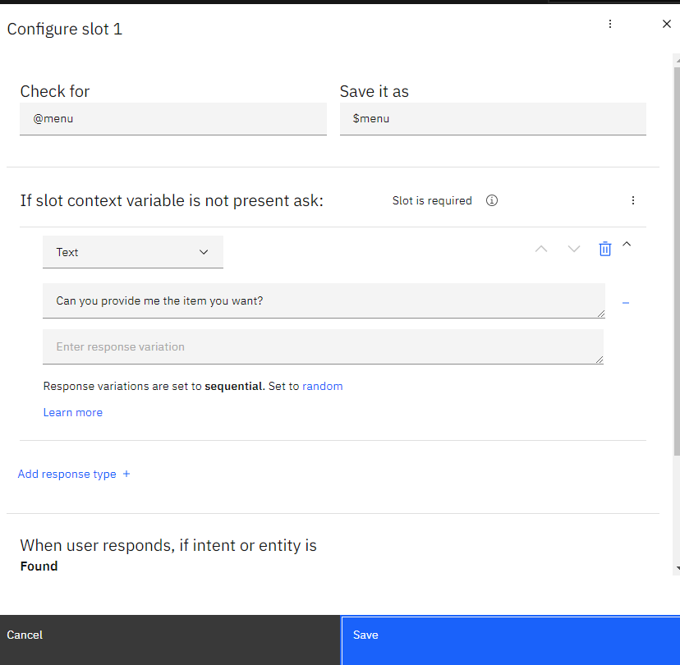
Step – 72: Click on Save
Step – 73: click on payment option give response like below

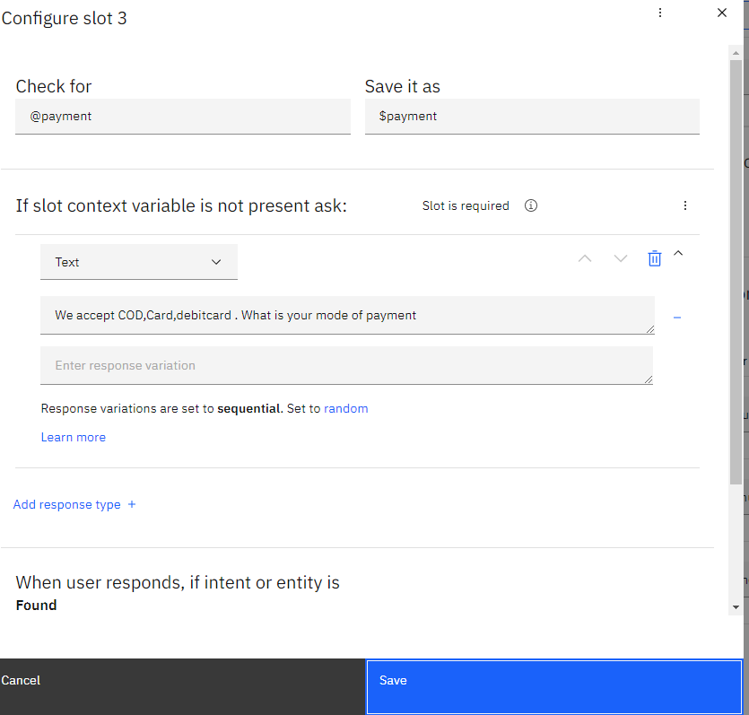

Step – 74: Click on Save
Step – 75: Enter input and observe the response as shown below
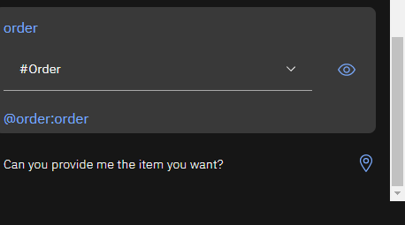

Step – 76: Click on Add Entity
Step –77: Give the name to the entity as “special items” and click on Create entity
Step – 78: Give sample food items in the items entity
Step – 79: You can also add synonyms for entities as shown below
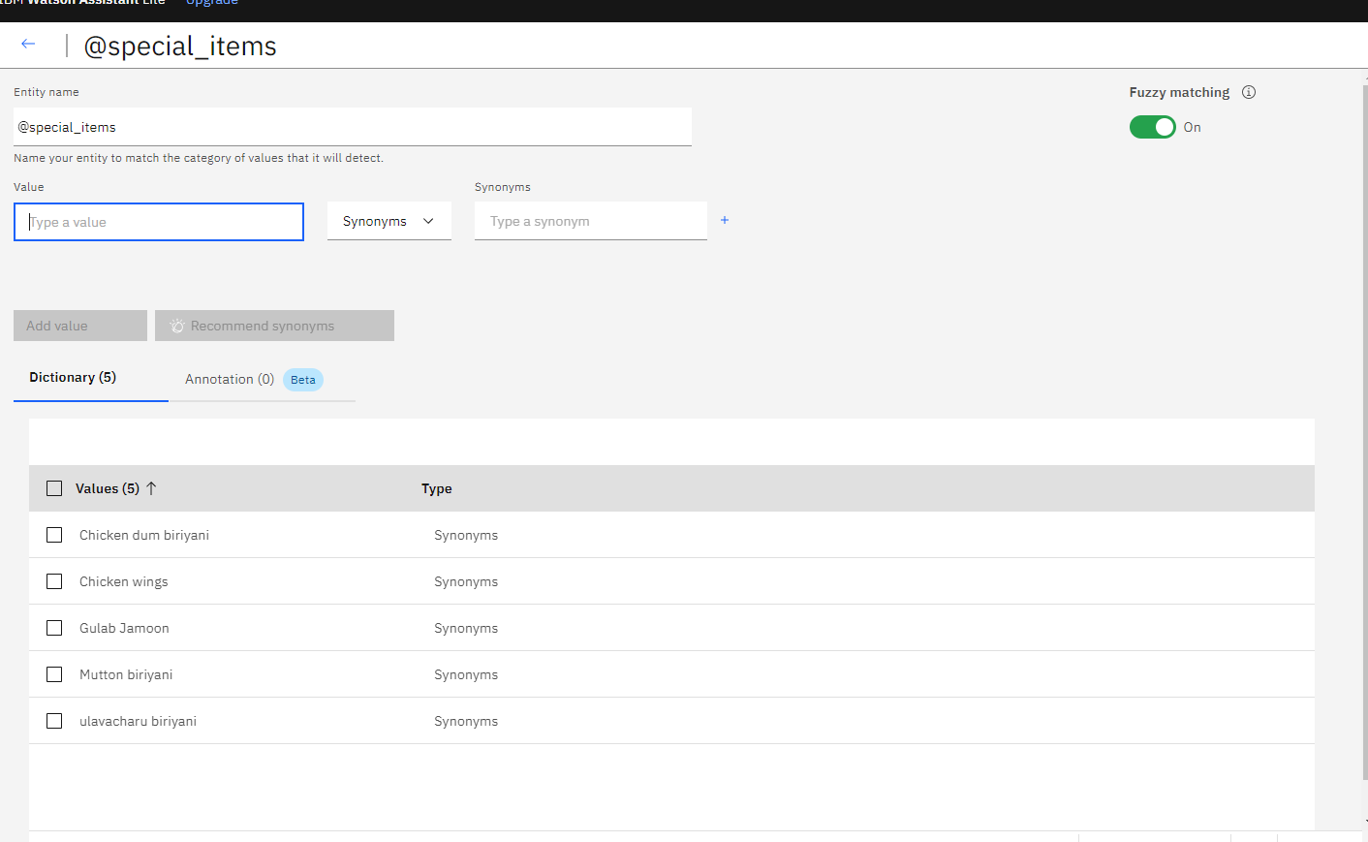
Step –80: After giving the sample food items click on the left arrow
Step – 81: Go to Dialog
Step –82: Click on enquiry 3dots Add child node for special items
Step – 83: Give the name of the node as special items
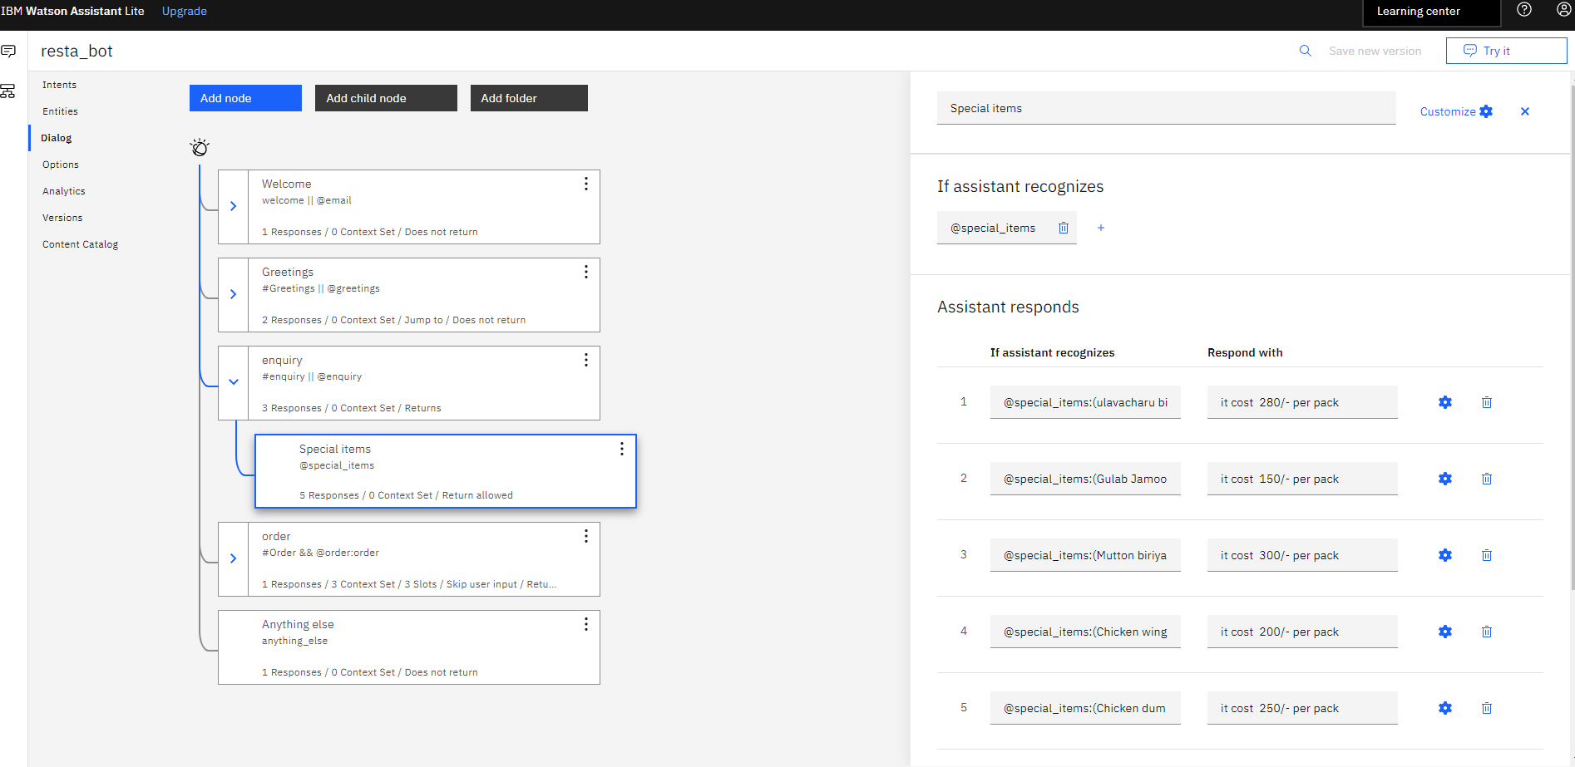
Step – 84: Click on “Customize” to give specific responses
Step – 85: Click X to close the edit window
Step -86: Test the dialog. Click the "settings" icon to open the "Try it out"
Step – 87 : Open edit window of order node
Step –88: Click on Customize to enable slots
Step – 89: Enable slots and click on Apply
Step – 90: In slots, we will check whether the user has mentioned item name or not. So in “Check for” enter the entity name “@items” as shown below.
Step – 91: If the user didn’t mention about the item, prompt for the information as shown below
Step – 92: Click on Add Slot and do the same thing for quantity
Step – 93: Click on Add response
Step – 94: Click on "settings" to add the internal condition
Step –95: Choose “@items” entity in condition and click to add other condition
Step – 96: Enter the condition
Step – 97: Enter the response
Step – 98: Again click on Add response and click on "settings" to add the other condition
Step – 99: In the edit window enter the conditions and response as shown below and click on save

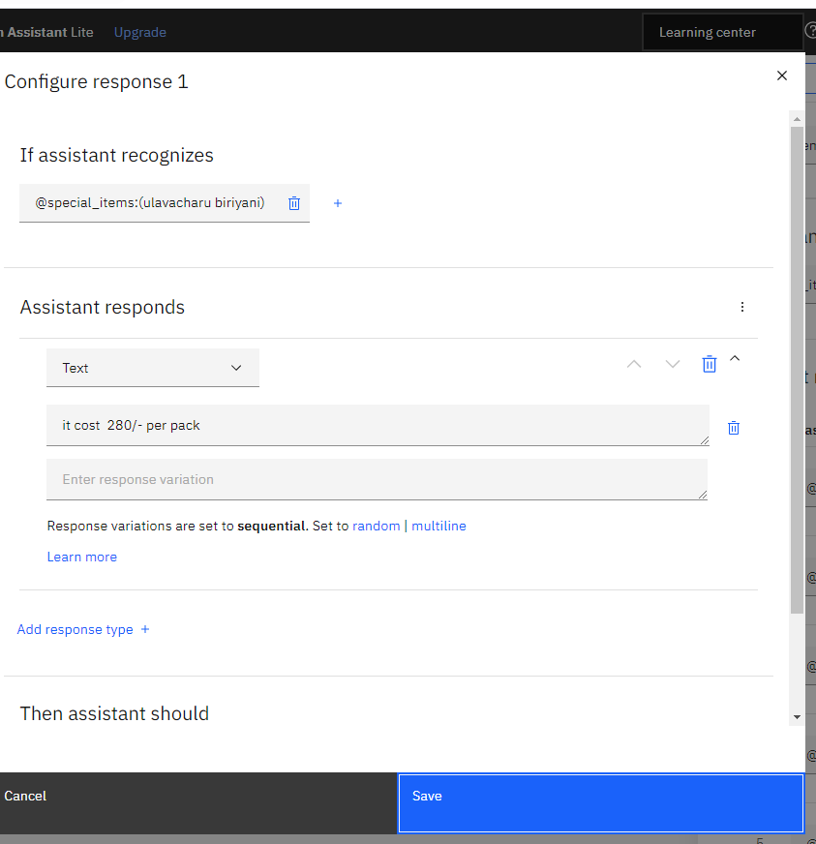
Step – 100: click on save
Step – 101: Click on “Customize” to give another responses
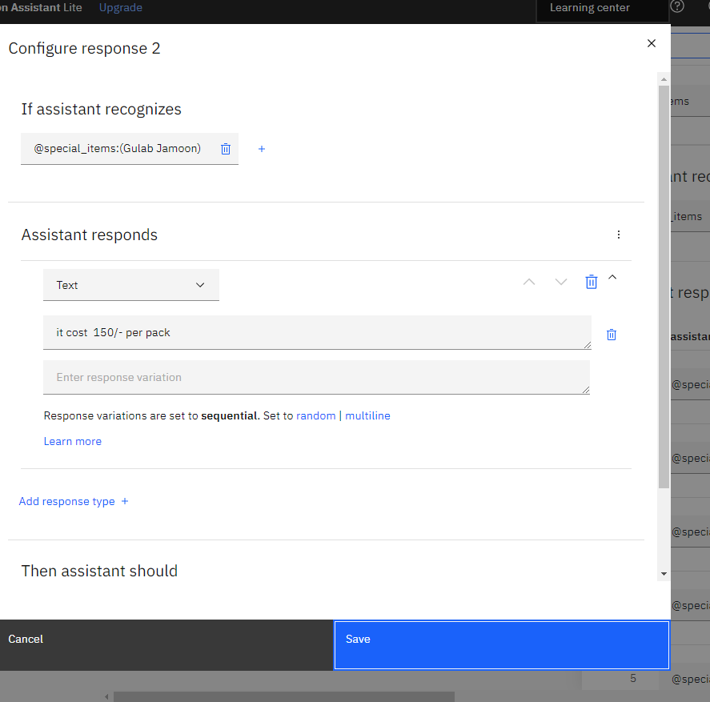
Step –102 : Click on Save
Step – 103 : Click on “Customize” to give another responses
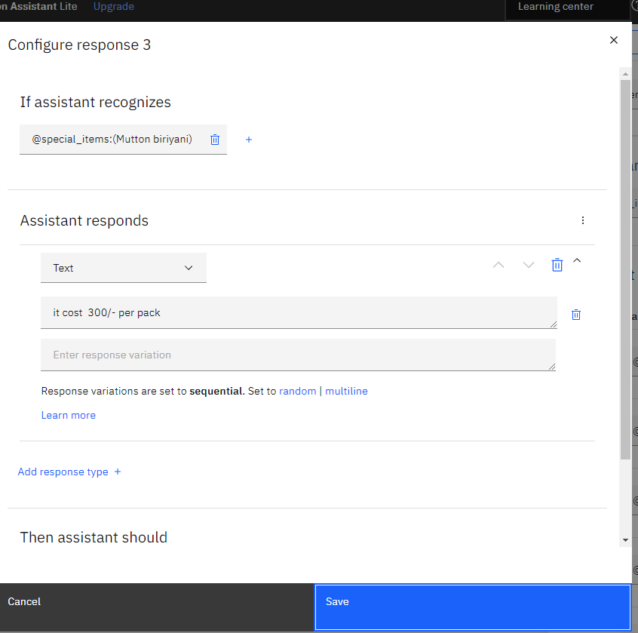

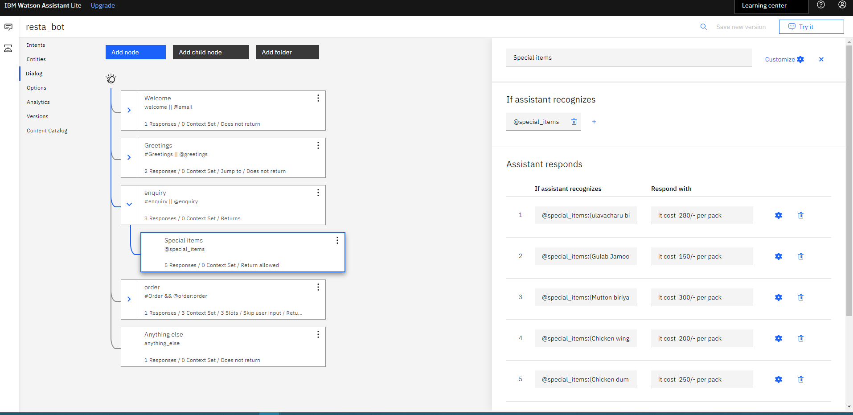

Step – 104: Enter the sample item name as shown below and now the bot asks for the quantity as it not mentioned
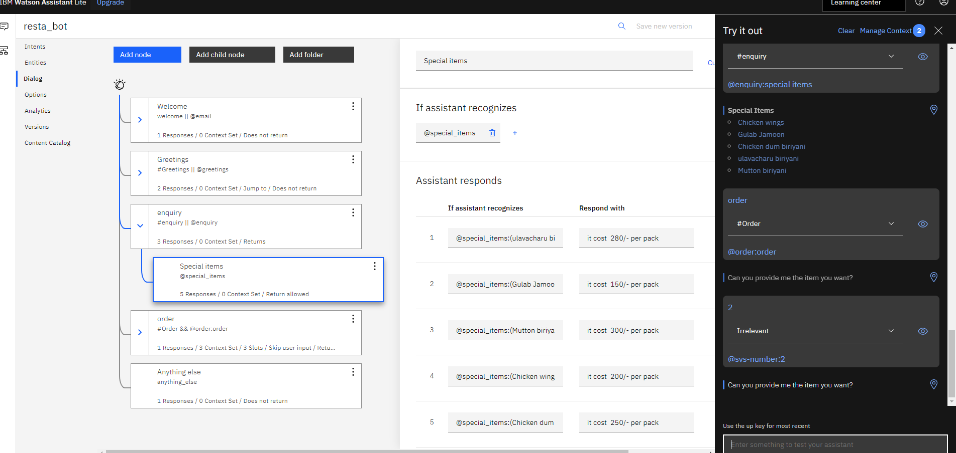
Step -105: Test the dialog. Click the "Try it " icon to open the "Try it out"
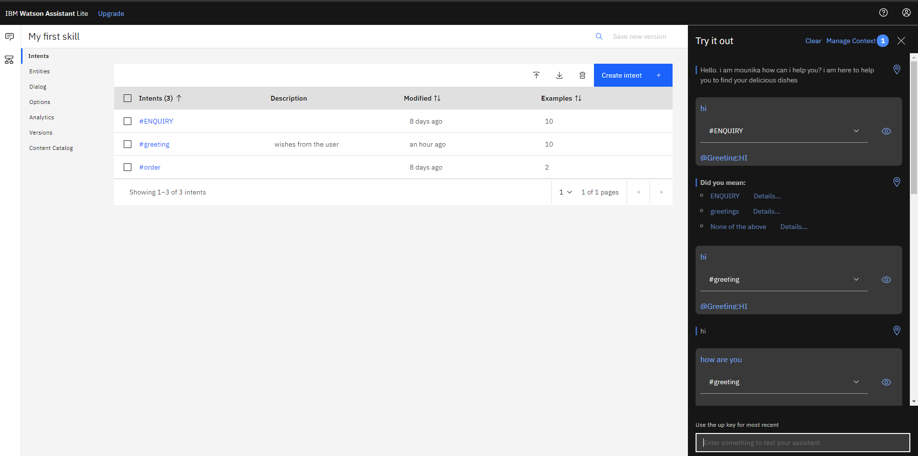

Step – 106: Click on Manage Context to check the saved context variable and click X to close the tab
Step – 107: Go to Dialog
Step – 108: Click on enquiry 3dots Add child node for deleting context
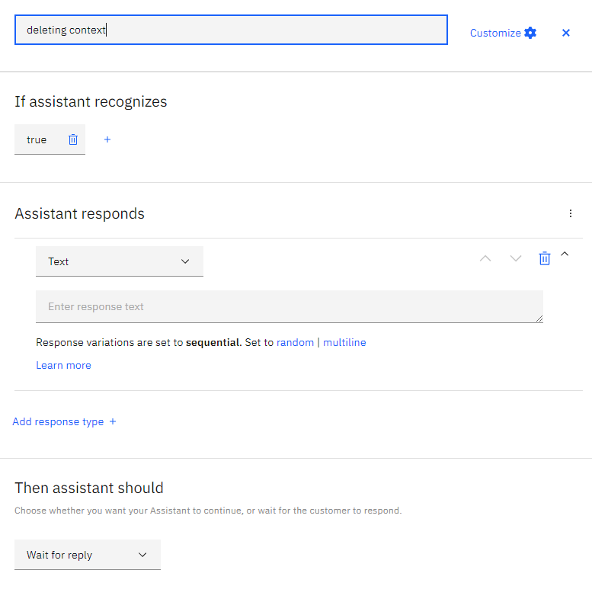
Step – 109: Go to Assistant responds click on 3dots click on open JSON editor
Step – 110: Here write code for deleting context & remove data context
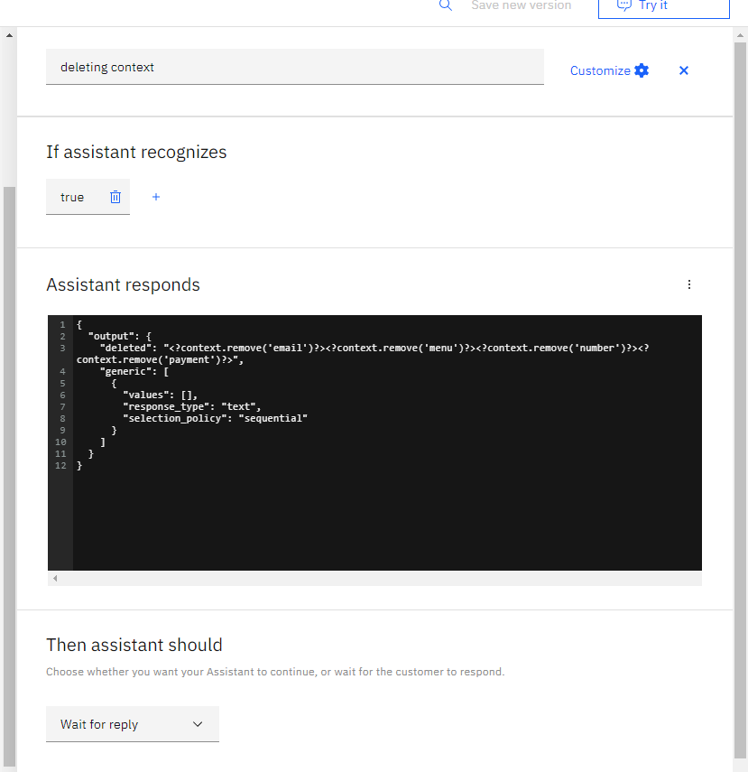

Step – 111: Click on Add Entity
Step – 112: Give the name to the entity as “email” and click on Create entity
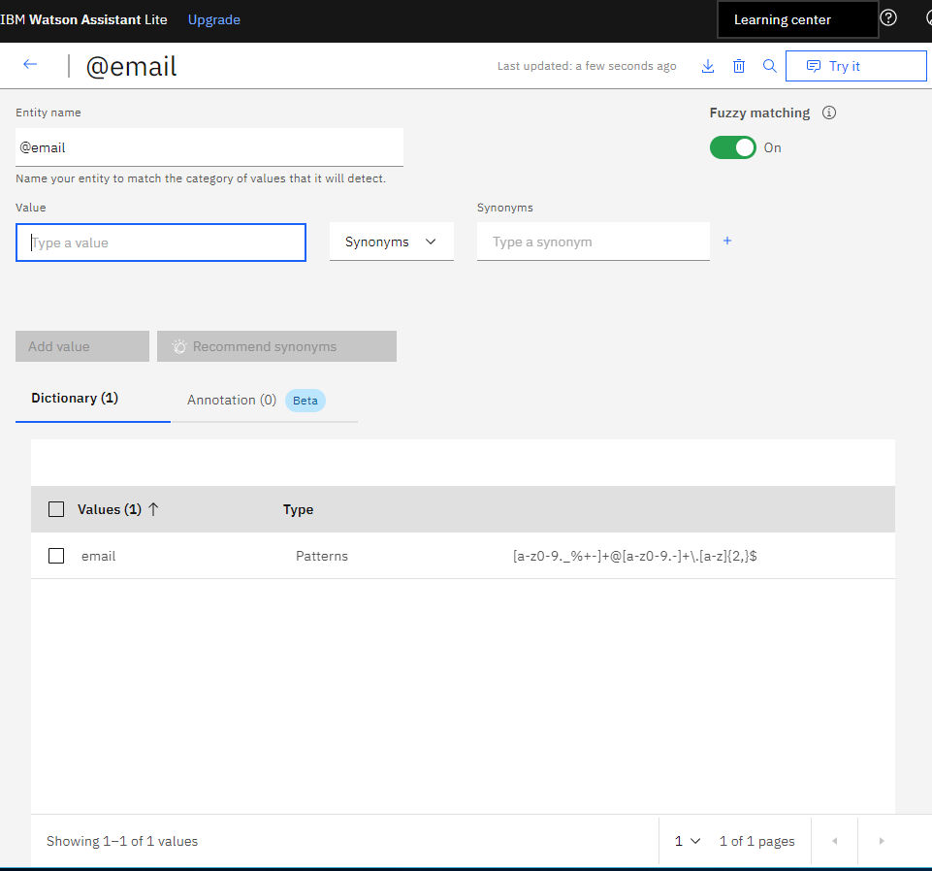
Step – 113: Go to dialog and click on
Step – 114: Click on welcome node 3 dots add child node to add a child node
Step –115: Give the name of the node as “mail id”
Step – 116: Give the response in the welcome node as shown below
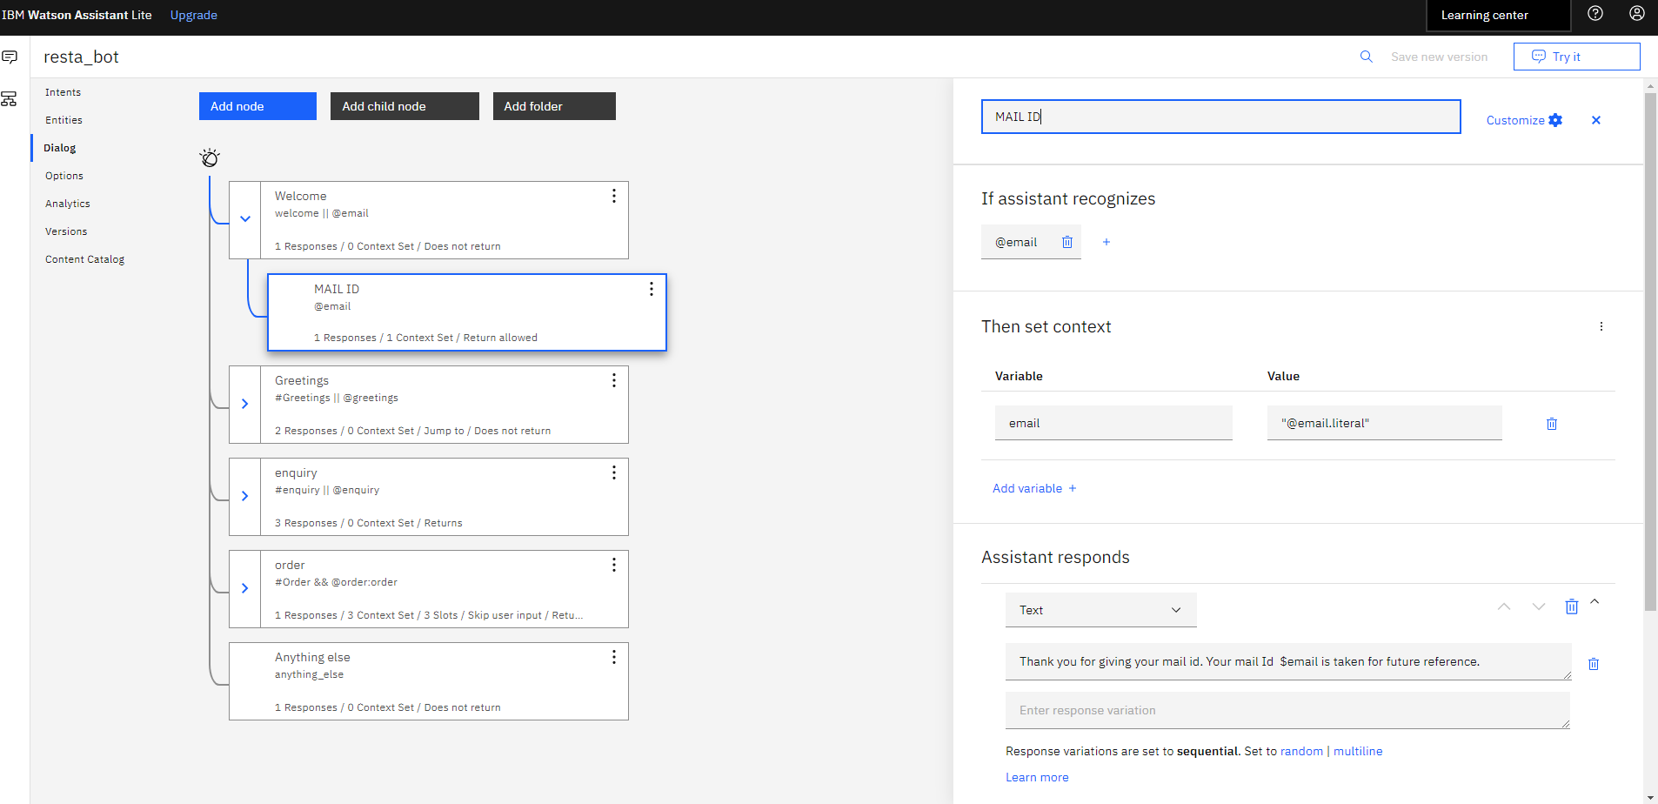
Step – 117: Test the dialog. Click the "Try it" icon to open the "Try it out"

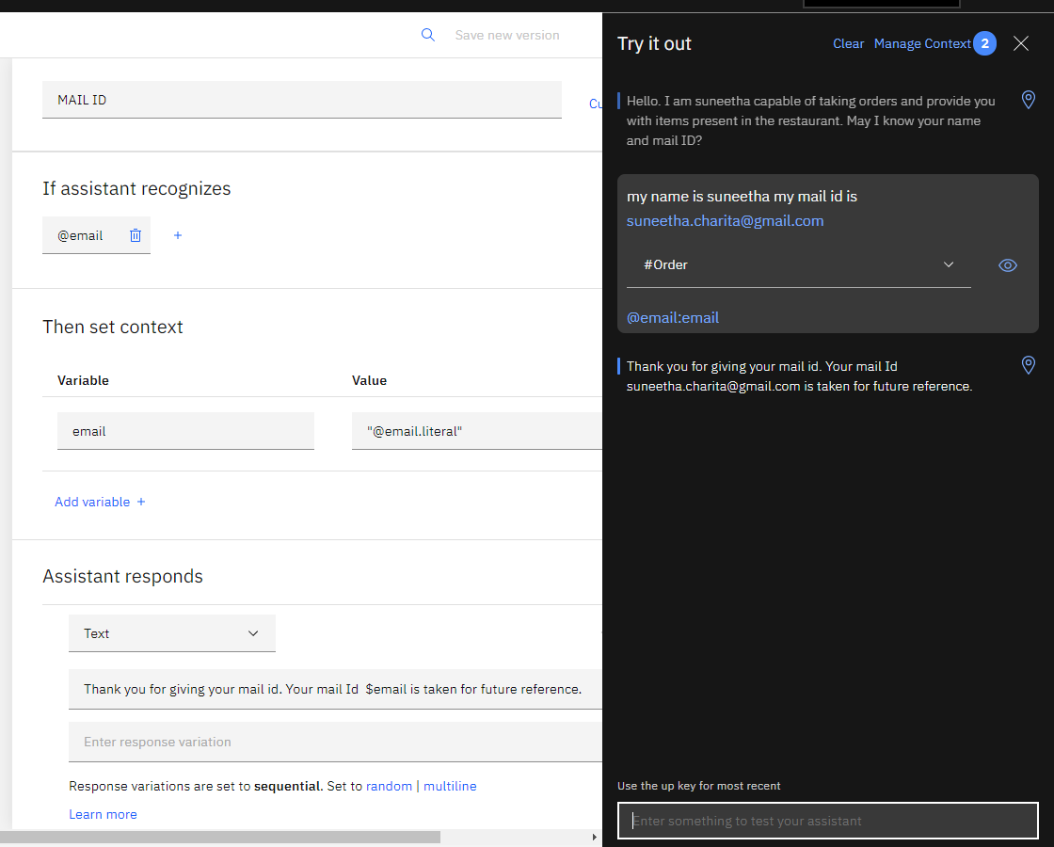

Step – 118: Go to Assistants click on Integrations and select preview link

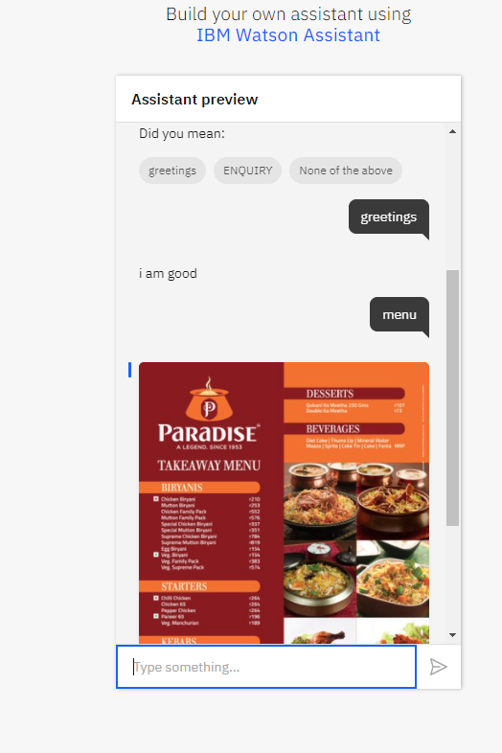
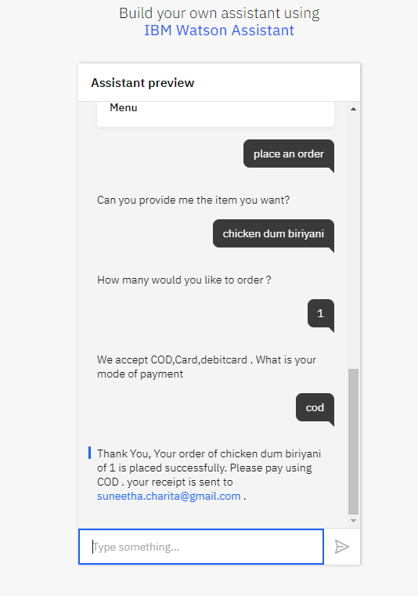
Step – 119: Go to Google chrome search Android Studio download and installed Android Studio
Step – 120: click on start a new Android Studio
Step – 121: click on file select new click on import project
Step – 122: Browse watson-android-master
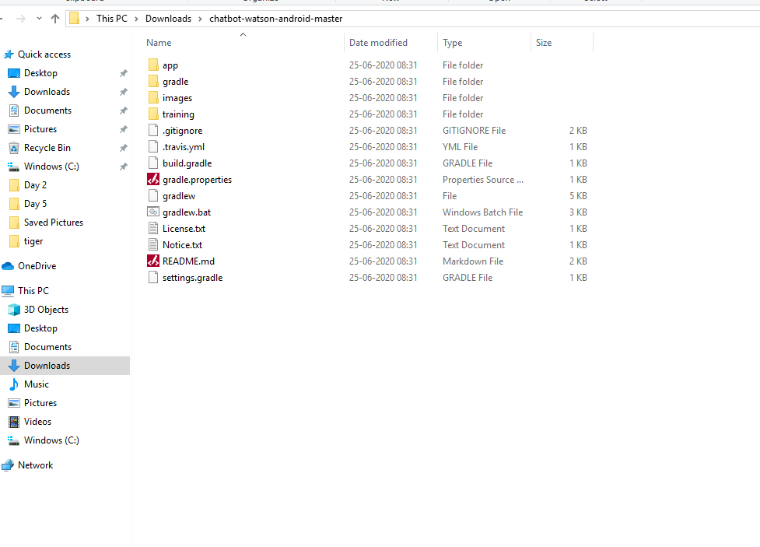
Step – 123: Go to apps select java
Step – 124: Click on res select config.xml.
Step – 125: Go to cloud Assistant
Step – 126: click on restaurant bot

Step – 127: select Assistant settings click on API details

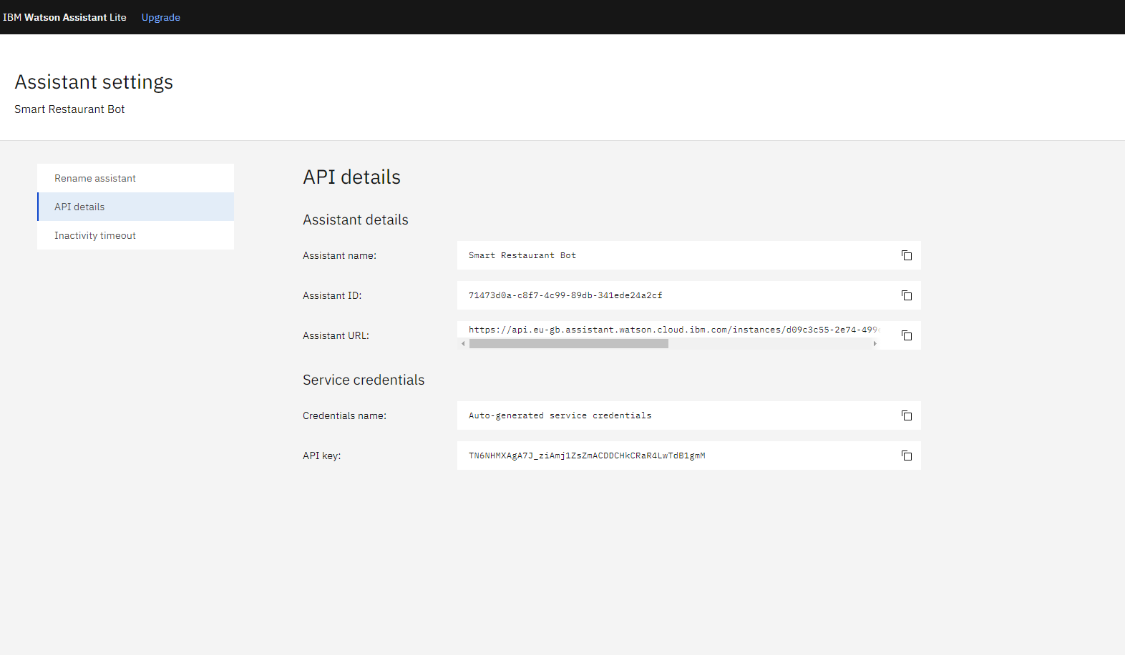
Step – 128: Go to Android Studio
Step – 129: Here paste assistant_id , assistant_apikey and assistant_url,
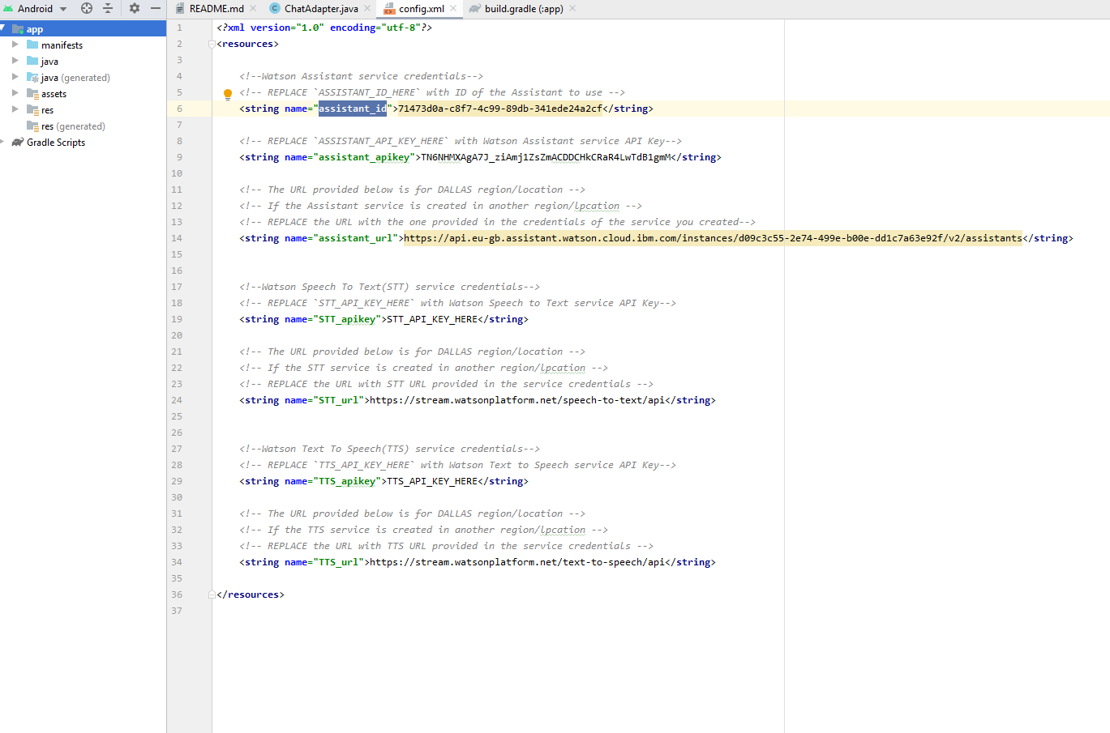

Step – 130: click on build.
Step – 131: download link on installed personal mobile.
